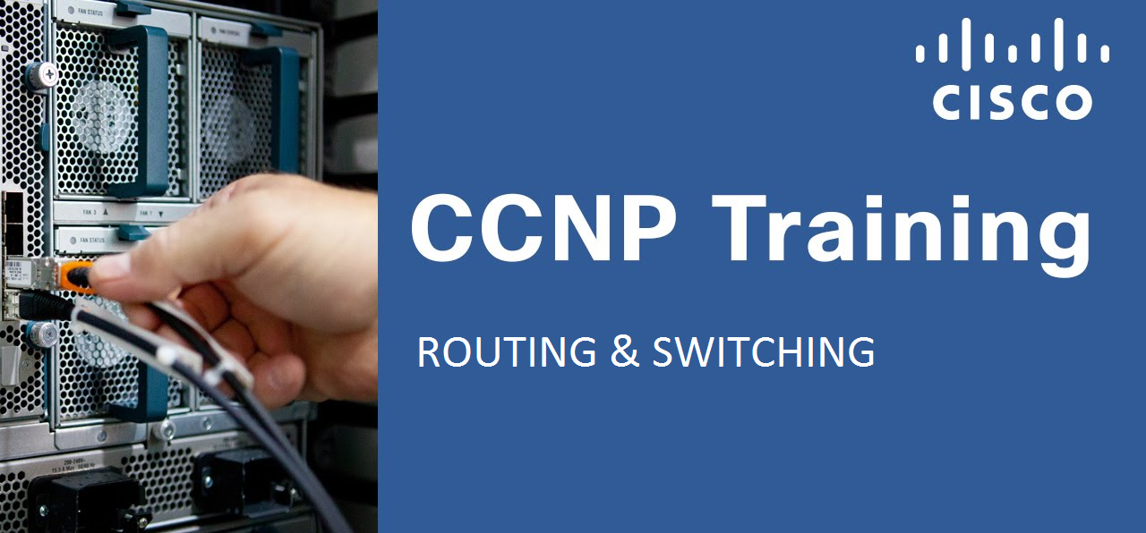ROUTE – Implementing Cisco IP Routing (300-101)

Pre-Requisites:
- CCNA – R&S
- Describing network fundamentals
- Establishing Internet and WAN connectivity (IPv4 and IPv6)
- Managing network device security
- Operating a medium-sized LAN with multiple switches, supporting VLANs, trunking, and spanning tree
- Troubleshooting IP connectivity (IPv4 and IPv6)
- Configuring and troubleshooting EIGRP and OSPF (IPv4 and IPv6)
- Configuring devices for SNMP, Syslog, and NetFlow access
- Managing Cisco device configurations, Cisco IOS images, and licenses

Course Content:
ROUTE v2.0 includes major updates and follows an updated blueprint. However, note that this course does not cover all items listed on the blueprint. Some older topics have been removed or simplified, while several new IPv6 routing topics have been added. Course content has been adapted to Cisco IOS Software Release 15 and technically updated. Course also introduces new type of labs, called discovery labs. Discovery labs are instructor guided lab through which student explores new topics in an interactive way. All labs are developed only as virtual labs.

Course Objectives:
- Describe routing protocols, different remote connectivity options and their impact on routing and implement RIPng
- Configure EIGRP in IPv4 and IPv6 environment
- Configure OSPF in IPv4 and IPv6 environment
- Implement route redistribution using filtering mechanisms
- Implement path control using policy based routing and IP SLA
- Implement enterprise Internet connectivity
- Secure Cisco routers according to best practices and configure authentication for routing protocols

Course Outline:
- Module 1: Basic Network and Routing Concepts
- Module 2: EIGRP Implementation
- Module 3: OSPF Implementation
- Module 4: Configuration of Redistribution
- Module 5: Path Control Implementation
- Module 6: Enterprise Internet Connectivity
- Module 7: Routers and Routing Protocol Hardening
- Labs:
  - Lab 1: Configuring IPv6 and RIPng
  - Lab 2: Configuring EIGRP for IPv4
  - Lab 3: Investigating EIGRP for IPv4 Behavior
  - Lab 4: Configuring EIGRP for IPv6
  - Lab 5: Configuring Named EIGRP for IPv4 and IPv6
  - Lab 6: Configuring OSPF for IPv4
  - Lab 7: Investigating OSPF for IPv4 Behavior
  - Lab 8: Optimizing OSPF for IPv4
  - Lab 9: Configure OSPFv3
  - Lab 10: Configuring Route Redistribution and Filtering
  - Lab 11: Configuring Path Control
  - Lab 12: Configuring Basic Internet Connectivity
  - Lab 13: Configuring BGP for IPv4
  - Lab 14: Configuring BGP for IPv6
  - Lab 15: Configuring EIGRP Authentication
  - Lab 16: Configuring OSPF and BGP Authentication

