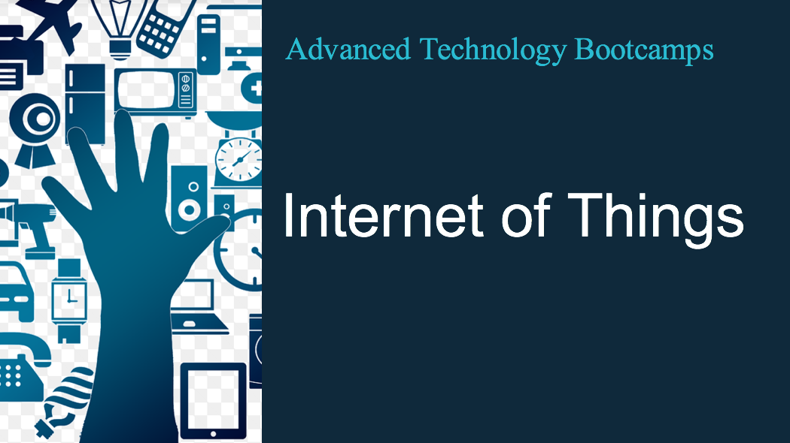

Internet of Things - Bootcamp

Pre-Requisites:
- Computer and IT Knowledge
- Internet knowledge
- Internet usage skills

Course Content:
The goal of this 2 day bootcamp is to unleash the buzz word “IOT” and understand the components involved in IOT. The bootcamp covers all aspects of IOT which one needs to learn to be a part of greater IOT revolution that is inevitable now. The bootcamp highlights IOT initiatives, IOT Ecosystem, IOT Security, best practices and practical real world examples and use cases

Course Outline:
  - What is IOT
  - Why IOT Hype
  - IOT Initiatives
  - How IOT works
  - IOT Architecture
  - Who is adopting and what are their challenges
  - Things to consider before implementation
  - Building an IOT ecosystem
  - Security and Privacy
  - Analytics in Digital Era
  - Sensors and Raspberry Pi
  - Home Automation
  - IOT platforms
  - Edge computing and Latest IOT Trends
  - Future IOT Projects and Initiatives
  - Best Practices

Labs
    - Real project in class with Raspberry Pi provided to each participant
    - Configuration of Raspberry pi
    - Adding Sensors
    - Control Sensors using Python program
    - Connecting to IOT Platform

