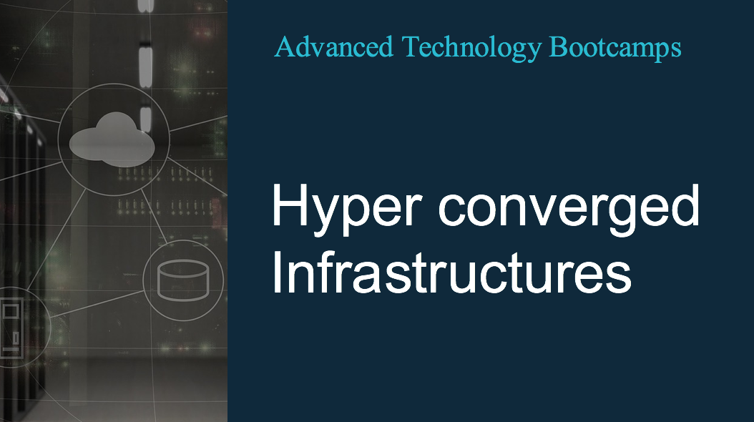

Hyper converged Infrastructures - Bootcamp

Pre-Requisites:
- Virtualization basics
- Storage, Compute and Network basics
- Datacenter Knowledge

Course Content:
This instructor led 1 Day bootcamp will give you a real insight to the next big wave in datacenter technologies which is Hyper converged infrastructures. The bootcamp is designed to walk participants through the components of HC Infrastructures and concepts like de-duplication, compression, IOPs, Erasure Coding and Log Structured File Systems. This vendor neutral bootcamp will also highlight performance analysis mechanisms and workloads assessments for the next generation datacenters

Course Outline:
  - What is Hyper convergence
  - HCI Concepts: Deduplication, Compression Erasure Coding
  - Log Structure File System
  - Distributed storage
  - Flash Endurance and wear leveling
  - Data locality vs Distributed architecture
  - Major HCI solutions
  - Nutanix
  - Hyperflex
  - VXrail
  - HP-Simplivity
  - All Flash Solutions
  - Performance assessment of HCI solutions
  - Application suited on Hyperconvered Infrastructures
  - On premise and public cloud integrations

Labs
    - Hands on Prism: Nutanix Interface
    - Hands on Hyperflex
    - Performance demos

