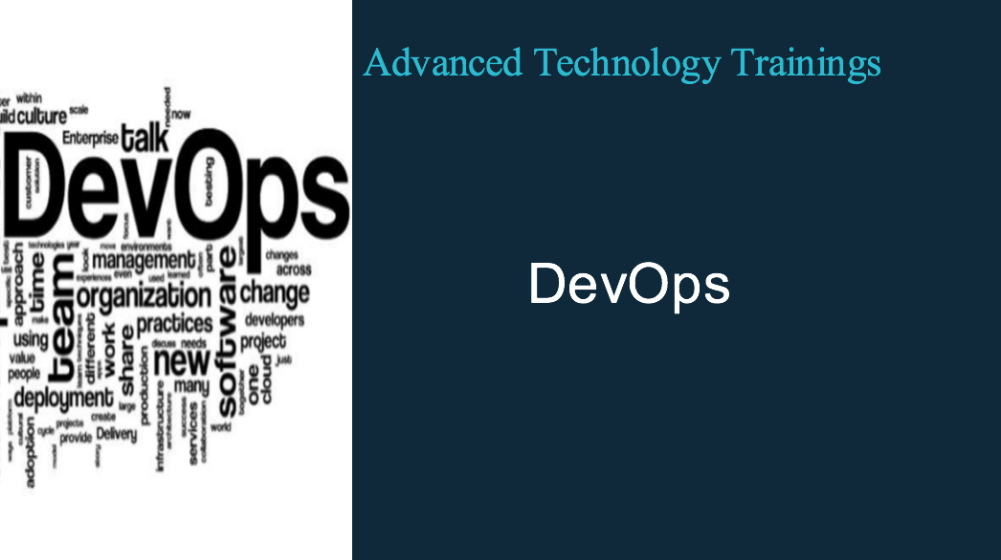

DevOps – 10 week Training

Pre-Requisites:
- IT background
- Computer Science Fundamentals
- Software Coding background
- Telecom, electrical or other engineering background

Course Content:

The goal of this 10 weeks training is to focus on the main concept of DevOps and
make participants knowledgeable about the tools and best practices required
to build DevOPs practice. This course will not only cover the methodology but will
deep dive into micro services architecture and deployment options like implementing containers and build container based applications

Course Outline:

Week1-2
- What is DevOps
- DevOps as a Culture
- DevOps as Methodology
- Core Concepts

Week 3-4
  - What are Microservices
  - What is Microservices Architecture
  - Monolithic vs Cloud Native Apps

Week 5-6
  - Container technologies
  - What are containers
  - Deploying Docker Containers
  - Difference between Virtual Machine and containers
  - Linking Containers

Week 7-8
  - DevOps tool that enable the whole process
  - Jenkins
  - Git
  - Se
  - Nagio
  - Kubernetes

Week 9-10
  - Mini Project

